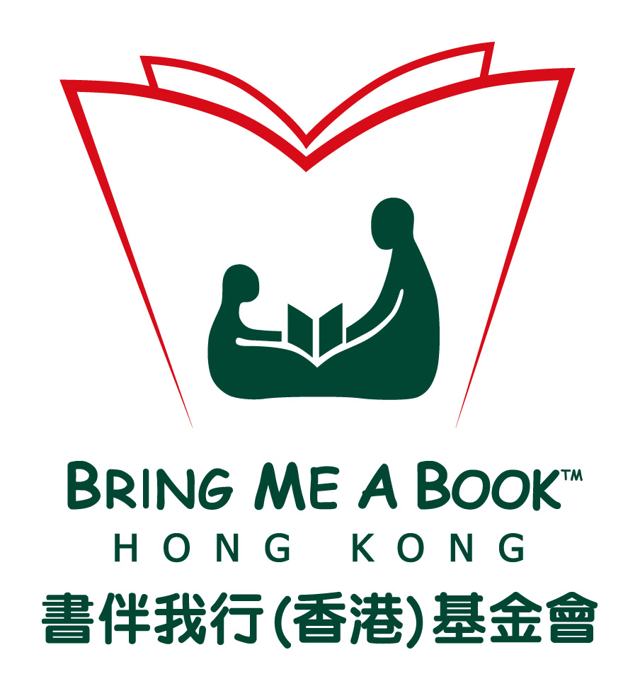

FOR IMMEDIATE RELEASE October 9th 2013

Bring Me A BookTM Hong Kong (BMABHK), the leading advocate of family literacy and authority in children’s book selection in Hong Kong, proudly presented “All Things Bright & Beautiful” Gala Dinner on October 4, 2013.

More than 540 guests attended the successful fundraising gala dinner, including a surprise appearance by supermodel Karolina Kurkova, held at the Convention Foyer and Hall, The Hong Kong Convention & Exhibition Centre.

In her opening speech, Board Chair of Bring Me A Book Hong Kong, Ms. Annie Ho, shared how Bring Me a Book has evolved over the past seven years, “While we continue to bring books to underserved communities and run training classes throughout Hong Kong, we are so much more than just books. We connect families and their community. We get children ready for the future. We transform lives.”

During the evening, guests enjoyed browsing an incredible pop-up “All Books Bright and Beautiful” Book Shop with 3,800 children’s titles in English and Chinese, including autographed copies of the 2013 winners of Feng Zikai Chinese Children’s Book Award. Mixologists, magicians and DJ Miles Slater were also on hand to entertain the guests.

In a three minute pledge session, a total of 50 libraries were generously donated. With the money raised, BMABHK will expand their outreach, targeting schools and community centers in ten low-income districts across Hong Kong, Kowloon and New Territories. Over 90 silent auction items were sold and guests dug deep to help raise a total of over HK$5.5million.

This was Karolina Kurkova’s first trip to Hong Kong and it was purely to help support the Bring Me a Book Gala Event as the charity was founded by her friends, James and Su Chen.
“It is so important to read books to kids and this is something I do with my three-year old son every night. It doesn’t matter what your status in life is, reading with your child is about quality time with mom and dad and opening their imagination,” shared Karolina Kurkova.

Prestigious guests in town participated in BMABHK’s Gala Dinner to offer their support, including former Financial Secretary of Hong Kong SAR Mr. Antony Leung Kam Chung and his wife, Michelle, acclaimed reading specialist Ms. Diane Frankenstein and education veteran Ms. Rowena Danziger who both flew in to Hong Kong to lend their support to Bring Me A Book.
Other notable guests include Ms. Irene Wan, Mrs. Sabrina Fung Lam and Mr. Kevin Lam, Ms. Tansy Tom, Ms. Leigh Tung, Mr. Stanley and Mrs. Jacqueline Sun, Ms. Joanna Hotung and Ms. Jennifer Yu.

2013 Fundraising Committee Members
Anne- Marie Munk Harvey Peggy Yeoh
Christabel Lee Pia Wong
Eizelle Taino Sabrina Fung
Jacqueline Sun Samantha Wong
Jennifer Yu Sharie Tse
Leigh Tung Shirley Hung
Lily Ahn Riddick Su Hwei Lee
Malti Dialdas Tansy Tom
Michelle Cheng Yama Gaw

About Bring Me A Book Hong Kong
Bring Me A Book™ Hong Kong (BMABHK) is a non-profit organization that was founded in 2006 to serve children who do not have access to quality books and who are not read aloud to on a regular basis. As the leading advocate of family literacy in Hong Kong, Bring Me A Book provides libraries and trainings for parents and teachers to foster an early love of reading and learning for all children.

The Problem

Many of our children lack the essential skills and resources to succeed in school. Out of 43 countries surveyed on reading habits Hong Kong ranked lowest in terms of motivation to read and family literacy. Only 12 per cent of Hong Kong parents engaged in some form of preschool literacy activities with their children, versus the international standard of 37 per cent.

Our Achievements

Over the past seven years, Bring Me a Book Hong Kong has installed 211 libraries, served 78,000 children and trained over 10,000 parents and teachers to read aloud effectively through our award-winning “First Teachers Training” program.

We have produced two popular “English Children’s Book Guides” for native and non-native English readers and we are pleased to launch the 2013 edition of our “Guide to the Best Chinese Books”, at tonight’s fundraiser gala dinner. Our guides are available on our website for free and so far, over 10,000 downloads have been recorded to date.

For more information, please see: www.bringmeabook.org.hk

Progress in International Reading and Literacy Study (PIRLS) 2011

